|  |  |  |  |  |  |
| --- | --- | --- | --- | --- | --- |
| Date | 7-Dec-22 | | | Tester Name | Mayuri Patel |
| Environment | Penfax - Test | | | Login used |  |
| Operating System | Windows | Version: | Update: | | |
| Software Used | Edge | Version: | Update: | | |
| Not Applicable | Version: | Update: | | |
| Release version | 22.4.1 | | | | |
| Title | External Transfer In | | | | |
| Test Type | Regression | | | | |
| Test Scenario | Process a transfer in from RRSP | | | | |
|  |  | | | | |
| Expected Results | Transfer In record should be available in Contribution History.  Transferred amount should be seen as a transaction record in Account Balances and Account Activity under Investments.  Member Deposit Letter should be generated in member’s account.  PEPP Valuation Report should show the transaction. | | | | |
| Pass/Fail | Fail | | | JIRA# | N/A |

Describe your steps with screenshots:

1. Open up any member. Member can be Active or Deferred.

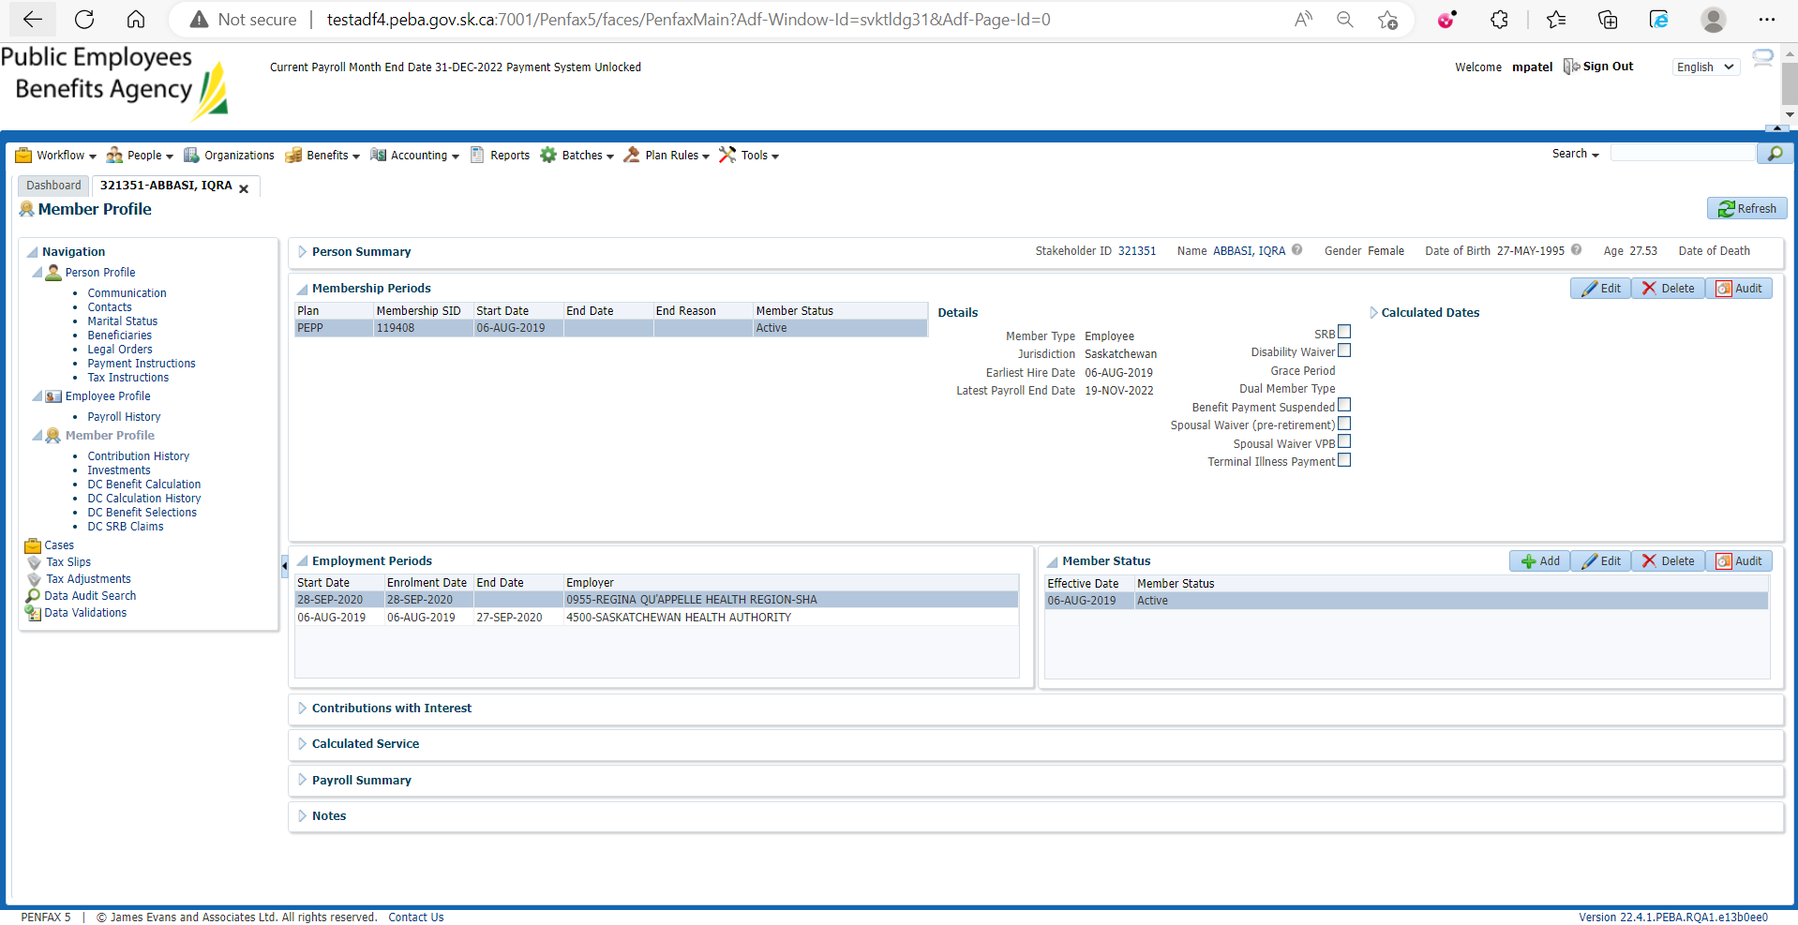

1. Go to Investments and record the current Locked-In [Saskatchewan] amount.

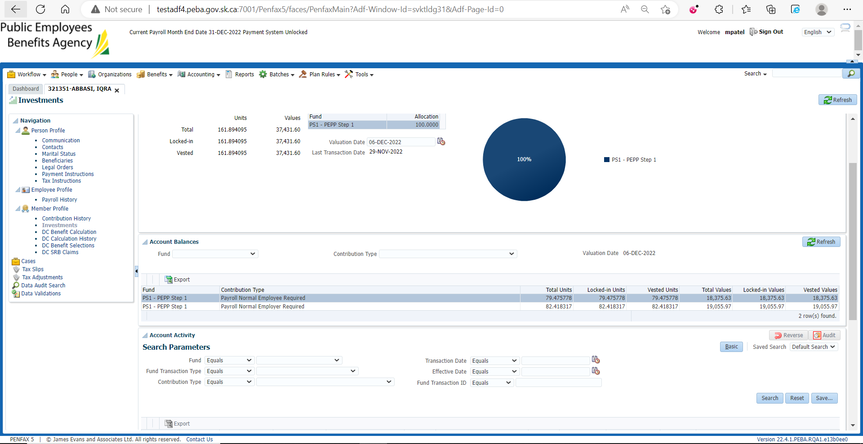

1. Go to Contribution History and click Add.

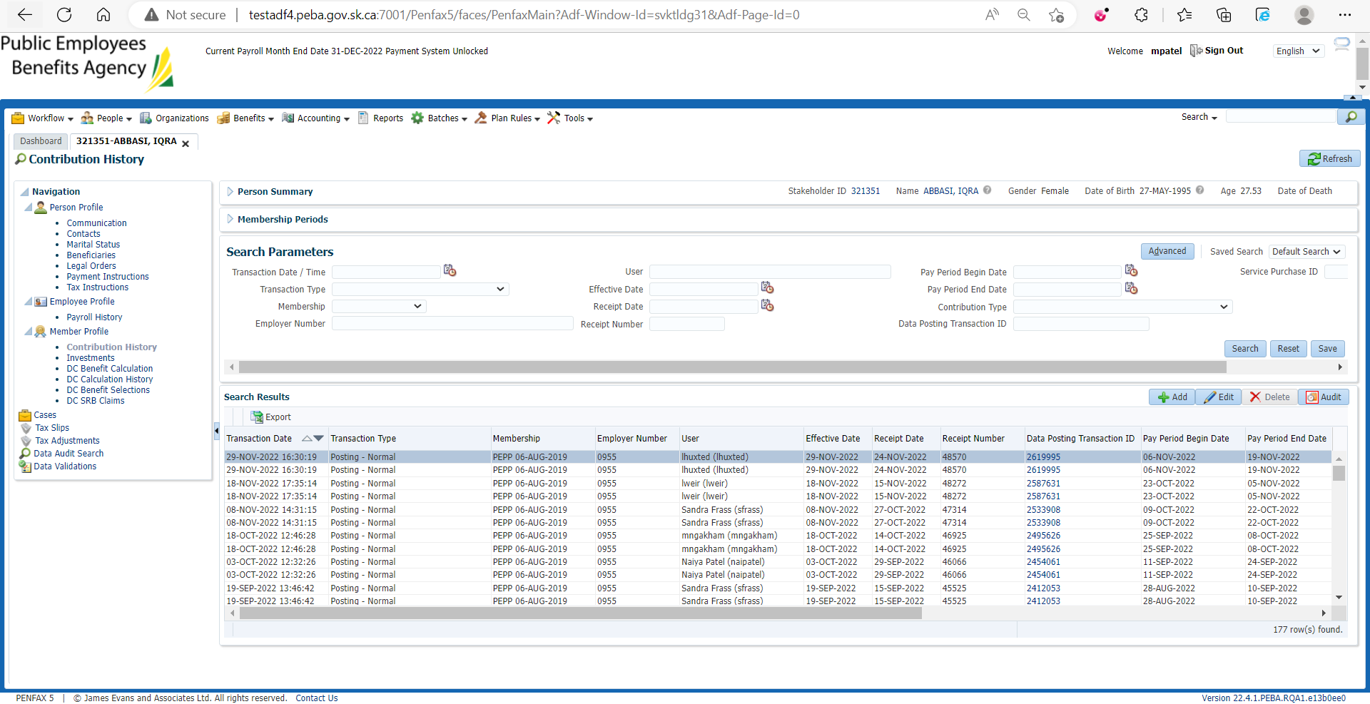

1. Under Membership the proper Membership period should default in.

Under Contribution Type Select Voluntary RRSP.

Under Effective Date select Today.

Under Amount, input an amount.

Under Note, put where the money came from. Ex RBC.

Hit Save.

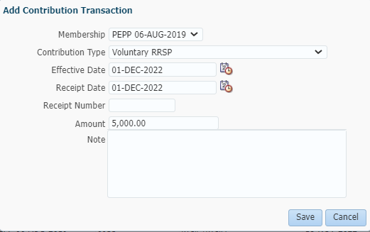

Enter Receipt Date and click Revalidate and Save. (if not done earlier)

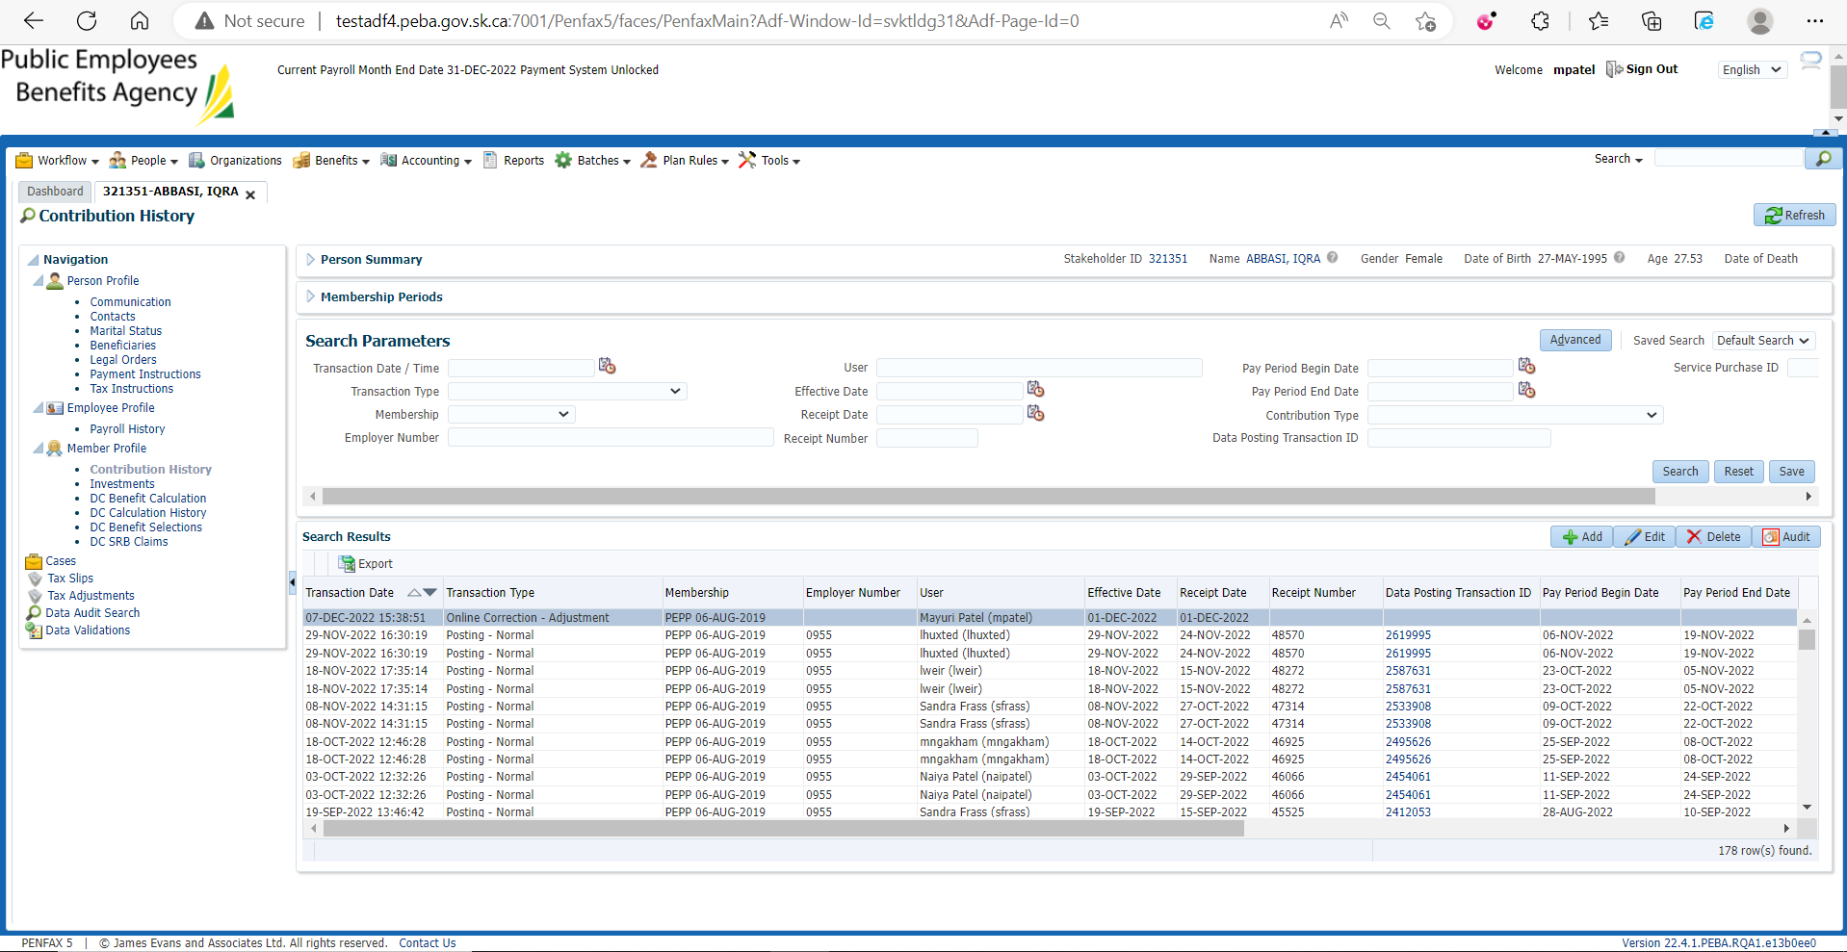

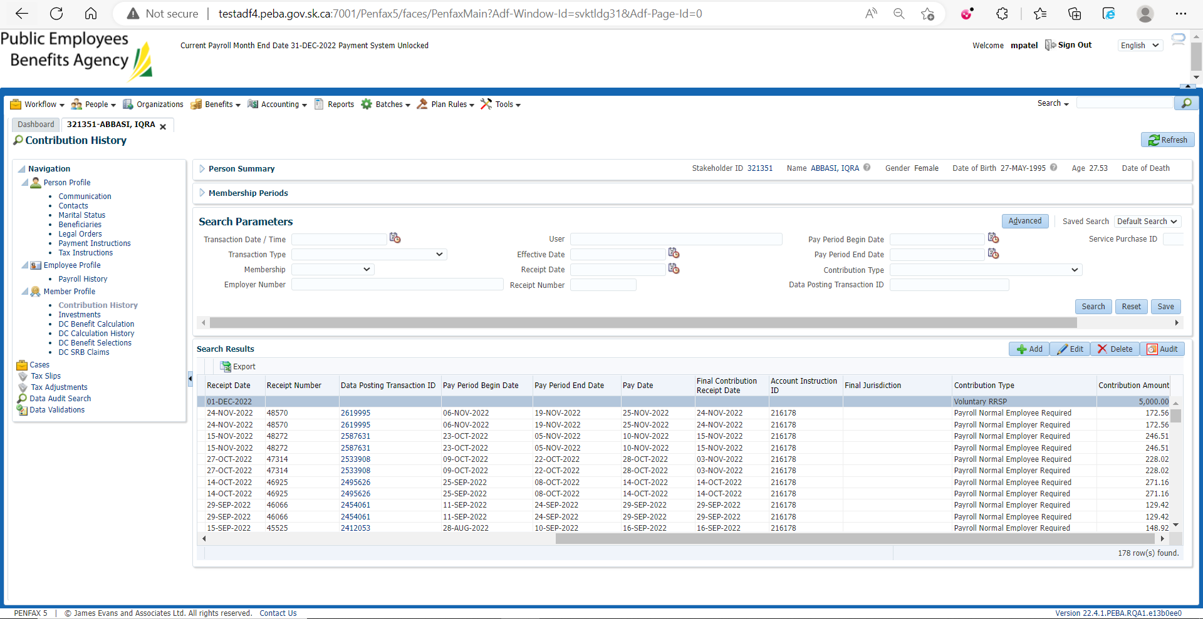

1. Wait for the next day, or process all the overnight batches to run.
2. Bring up the member again in PENFAX5. Go to the Investments Tab. Make sure the money shows up in the balance of the account. Also check the Deposit Allocation. Make sure the funds went into the correct account.

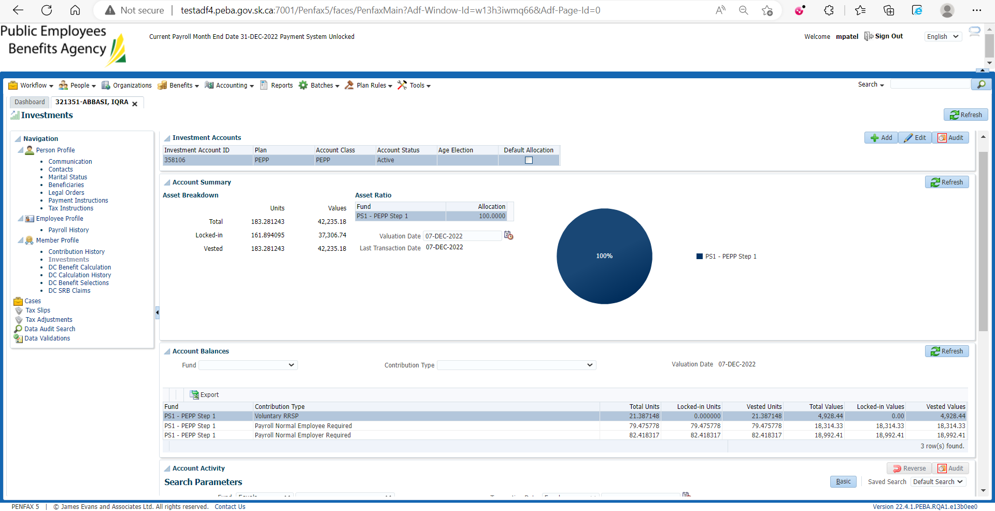

1. If you do a search under account activity it should show the transaction.

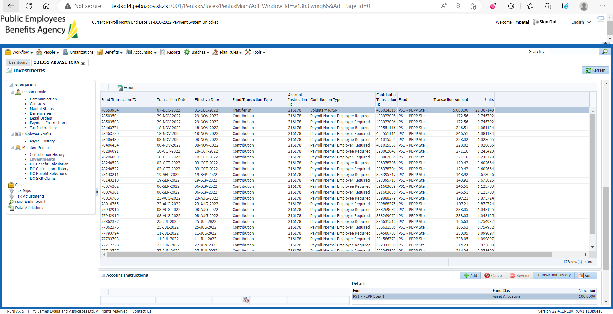

1. Go to the Communication tab. There should be a member deposit letter saved under Outbound Documents.

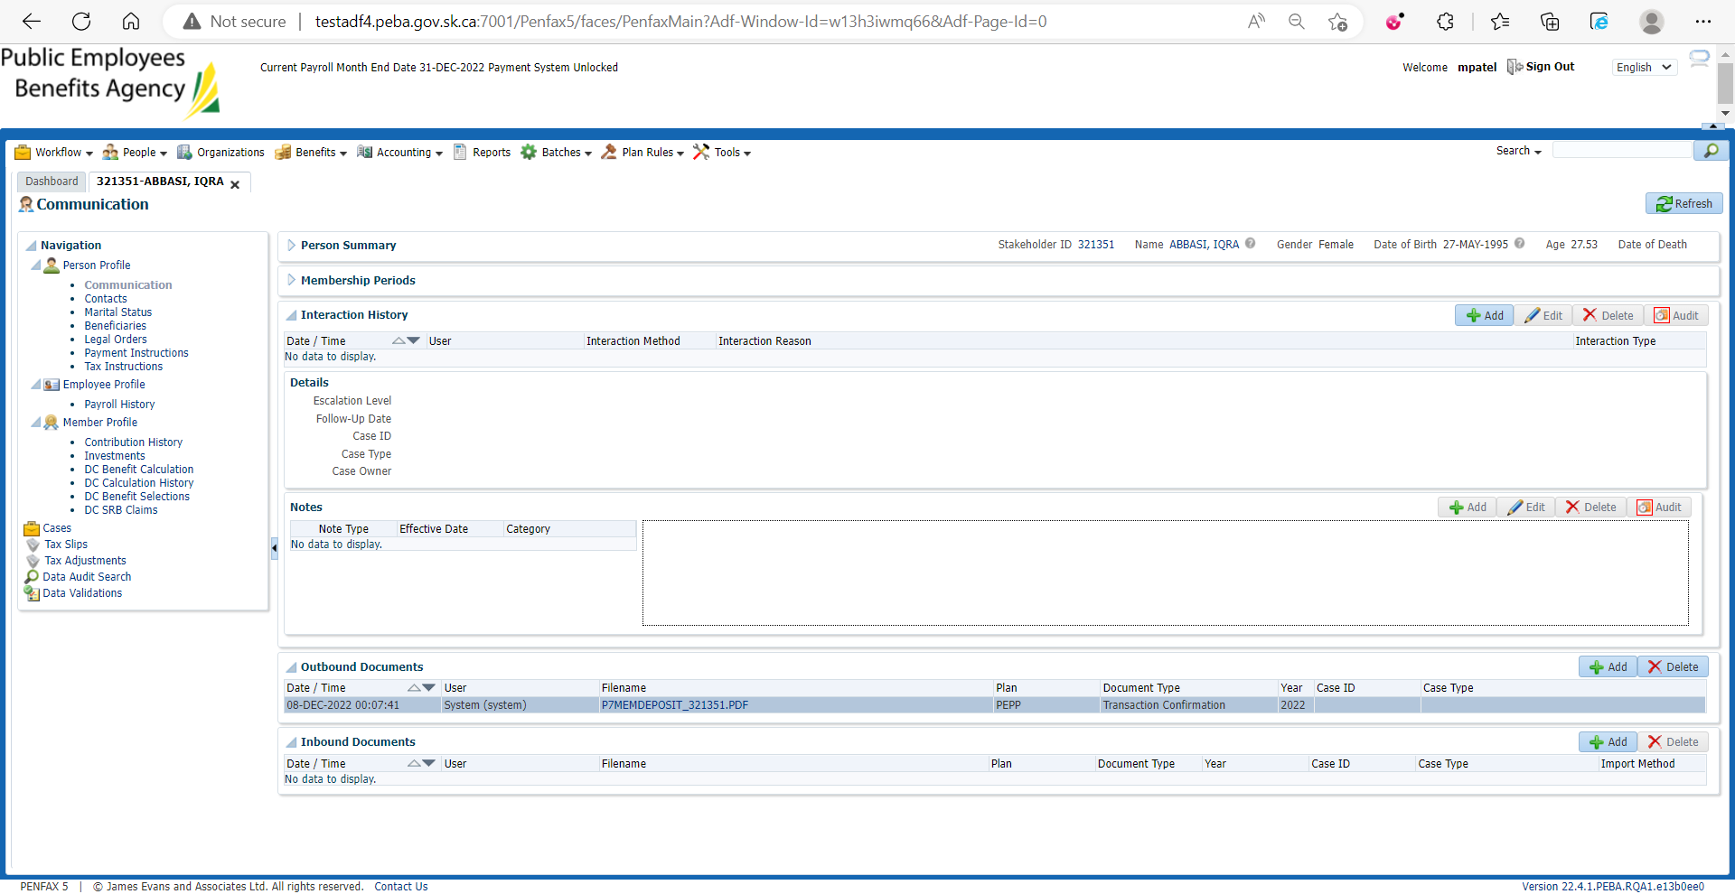

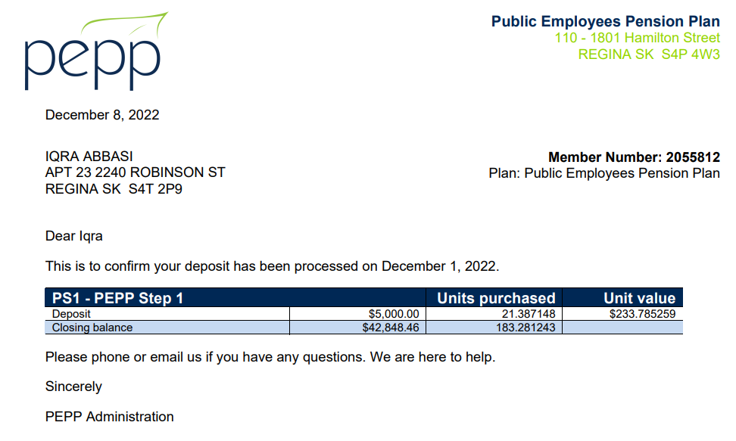

1. Go to Batches -> Batch Process -> Search for PEPP Valuation Report.

On Section Two tab:

